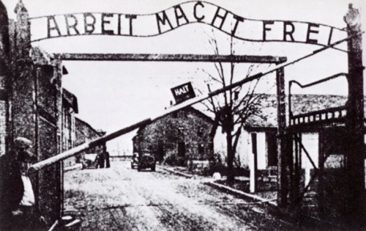
The ABC’s of World War II
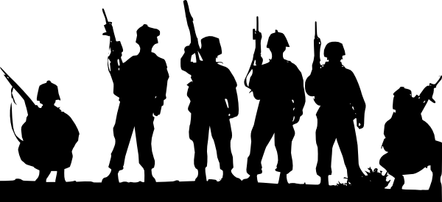

Ms. Baker
US History A
Hour
Date

Auschwitz
Auschwitz is one of the most well known concentration camps from WWII. It was the largest camp that was established by the Nazi’s. There were three camps that were a part of Auschwitz, Auschwitz I, Auschwitz II-Birkenau, and Auschwitz III-Monowitz. It was part of the “final solution” and Jews were delivered to the camp and controlled by the SS. Prisoners were treated harshly, starved, tortured, beat, and many were sent to the gas chambers and killed. It was liberated on January 27, 1945, by Soviet troops.

Blitzkrieg
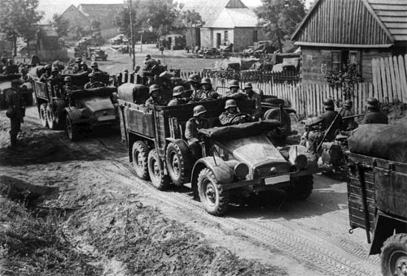

Blitzkrieg means “lightening war”. World War II was the first time this war strategy was used. It is based on speed and surprise, designed to hit hard and then move on quickly. It was developed by a German officer and it was used against in Poland, Western Europe on the beaches of Dunkirk, and also in the German’s attack on Russia. Planes were sent in to bomb, distracting the victims while tanks were approaching on land. It was extremely effective in all of its attacks.
Camaraderie can be defined as mutual trust and friendship among people who spend a lot of time together. In relation to World War II, camaraderie was shown a great deal between soldiers, pilots, alliances, and world leaders. Without trust, nothing would have been accomplished, either positively or negatively. An example of camaraderie was between the Axis Powers, Germany, Italy, and Japan, and between the Allied Powers, England, USA, USSR, and France.

Camaraderie
